

|  |  |  |  |  |  |  |  |  |
| --- | --- | --- | --- | --- | --- | --- | --- | --- |
|  | | | | | | | | |
|  | | Calibration of the IMU sensor (BNO 055) | | | | |  | |
|  |  | | | | | | |  |
|  | | | |  |  | | | |
|  | | | | Arnav Jagtap |  | | | |
|  | | | | April 21, 2025—Project Course EE 299—Prof. Uttama Lahiri |  | | | |
|  | | |  | | |  | | |

# Introduction:

# In this study, we performed a calibration of the BNO 055 IMU sensor using a stepper motor to ensure accurate orientation readings. The IMU sensor used in the study of the bending angle of the body on the Wii balance board. Calibration is needed in our study for reliability of the biomedical study and calculation.

# The calibration process involved measuring the IMU’s orientation about roll, pitch, and yaw axes by mounting it on a stepper motor. We compared the data calculated from the stepper motor and IMU sensor i.e. when motor moves for 1.8 degrees then we observed the angle moved by the IMU sensor. Excel, Jupiter notebook, MATLAB and Arduino were used for the data collection and the analysis with the help of plots.

# Experimental Setup:

Equipment and Tools:

* Stepper Motor
* Arduino UNO
* HW 130 Motor Driver
* Adafruit BNO 055 Absolute Orientation Sensor
* MATLAB
* Arduino IDE
* Excel
* Jupiter Notebook

# Methodology:

Figure 1

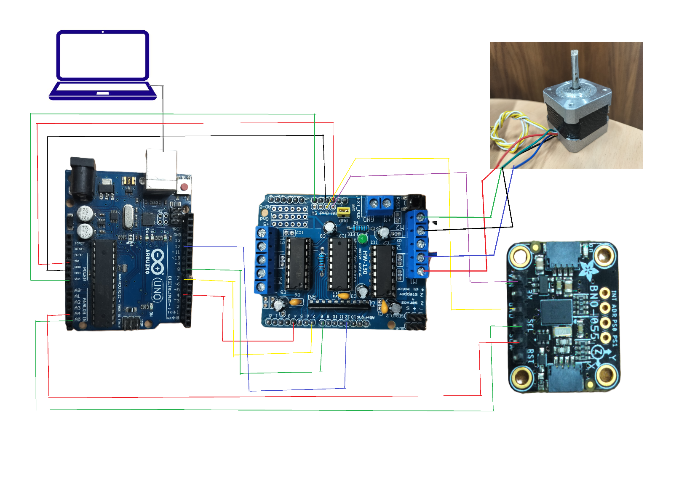

Figure 2

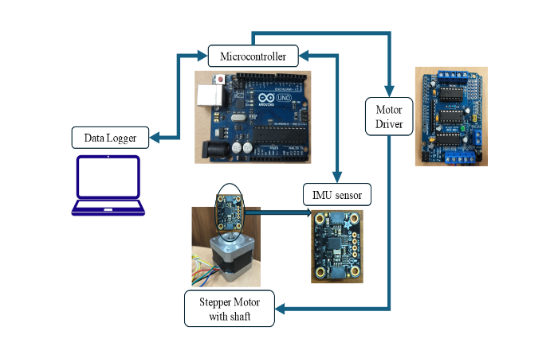

Figure 3

1. Preliminary Testing: The IMU sensor was initially tested in free space that is we moved it randomly in free space to check functionality and output characteristics.
2. Setup: The IMU sensor was mounted on the stepper motor as shown in Figure 1. Then we allowed the IMU to rotate about one axis at same time with stepper motor. We captured data for roll, pitch, and yaw orientations in separate tests. The stepper motor was connected to the HW 130 motor driver via the M1 and M2 slots. The motor driver was interfaced with the Arduino UNO using digital pins 4, 7, 8, and 12.
3. Motor Control and Data Collection: A calibration code was uploaded to the Arduino UNO. This code controlled the stepper motor to rotate while simultaneously we recorded orientation data from the BNO 055 IMU sensor. Serial data from the IMU sensor, including observed orientation angles and given angle rotation to the stepper motor, was captured and saved as a .csv file using MATLAB.
4. Data Processing: The collected data was imported into Excel for visualization. Rough graphs were plotted to compare the observed orientation angles (from the IMU sensor) and the actual rotation angles (from the stepper motor). This comparison helped evaluate the sensor’s accuracy and identify any systematic biases or errors in its readings.
5. Final plotting: We send the data from the Excel to Jupiter notebook and then we calculated the regression coefficient and the approximate angle of the observed angle. For most accurate data the observed angle should be 450

# Results and Analysis:

Each of the roll, pitch, and yaw angles recorded using the IMU sensor were found to have good agreement with the predefined angles of rotation of the stepper motor as evident from the minimum value of regression coefficient (R2) being 0.9788. We have observed that the most accurate angle measurement is for the Yaw. We can use Yaw for the further measurement of the bending angle of the body and. For improved linearity and accuracy, we considered the Yaw component (having the slope ∼450) of the IMU sensor.